Life Cycle
of a
Mealworm

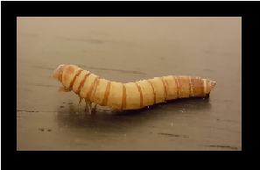

By:_______________

Initial observations of your mealworm.
How long is your mealworm? ______________________ How much does it weigh? _________________________
What does it eat? _______________________________
Draw a sketch of your mealworm.

What animal class does the mealworm belong to? ______________
What is your hypothesis for what you think you are going to
observe over the next several weeks? ________________________
_______________________________________________________
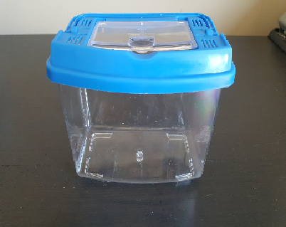
Observations:
________________________________
________________________________
________________________________
________________________________
________________________________
________________________________
Observations:
________________________________
________________________________
________________________________
________________________________
________________________________
________________________________
Observations:
________________________________
________________________________
________________________________
________________________________
________________________________
________________________________

Now that you have observed the life cycle of a mealworm, draw
a diagram of each stage and label it.

Life Cycle of
a Mealworm

How has your mealworm changed?
_______________________________________________________ _______________________________________________________
What was the most interesting part of this experiment for you?
________________________________________________________
________________________________________________________

What surprised you most about this experiment?
_______________________________________________________
________________________________________________________

