[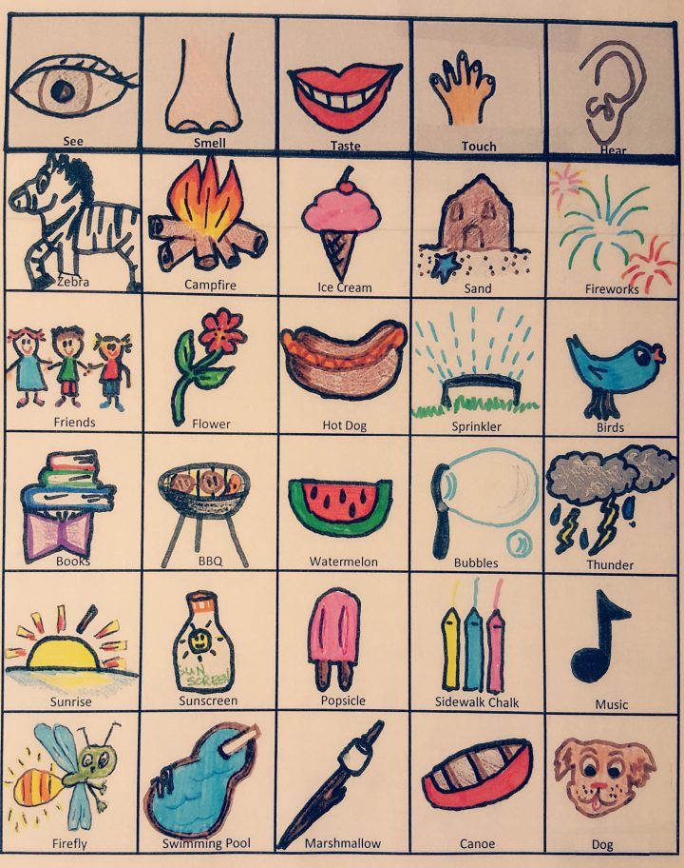](http://teachingideas.ca/wp-content/uploads/2018/08/PicsArt_08-29-10.21.06.jpg)