Community Helpers

Doctors

Look at all the tools that a doctor uses. Can you figure out what they are for? Doctors help to keep us healthy. Pretend that you are a doctor and use the different tools.

**[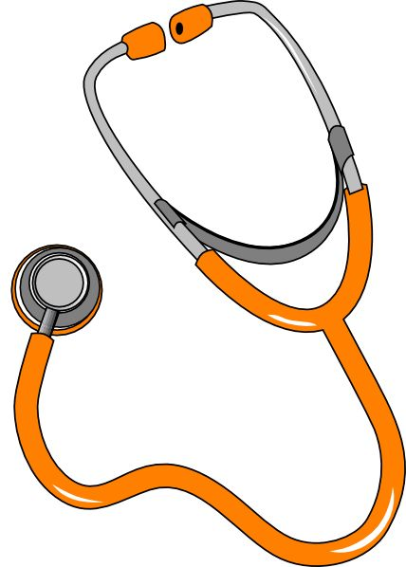](http://www.clipartlord.com/category/miscellaneous-clip-art/medical-clip-art/)**

Community Helpers

Fire Fighters

Can you put together the city? Fire fighters are always ready help anyone in the community. We need them in case there is a fire. Put the people and cars in the correct places within the community.

**[](http://www.clipartlord.com/category/miscellaneous-clip-art/medical-clip-art/)**

Community Helpers

Construction Workers

Can you help build? Construction workers help to build in our community. This may be houses or even roads. It is a lot of hard work!

Your job today is to help construct a house using the logs. What will your house look like?

**[](http://www.clipartlord.com/category/miscellaneous-clip-art/medical-clip-art/)**

Community Helpers

Dentist

Dentist help people take care of their teeth. They clean and check everyone’s teeth and help keep them healthy.

You get to be a dentist for the day. Can you make a set of teeth for the patient?

Community Helpers

Chef

A chef cooks food in a restaurant. They create menus and prepare food. Today you will be a chef. Set a table for your guests and cook a meal for them. Be creative!

Community Helpers

Video

Today you get the chance to watch a video featuring the different community helpers. Watch for details, such as the uniforms they are wearing and the tools they are using.

Community Helpers

Puppets

At this centre, you get to play and pretend with different community helper puppets. What would these helpers often say? What would they do? Try to make your puppet act in the way you think that the helper would.